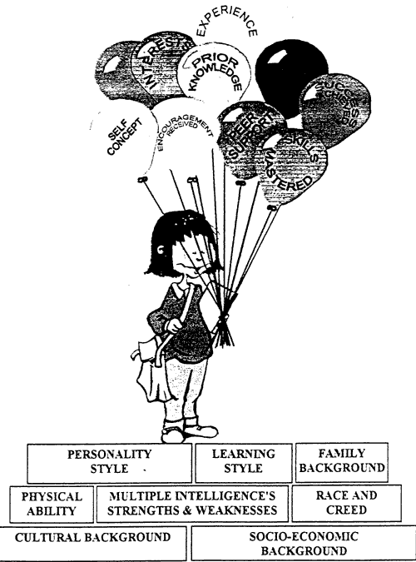
Assessment Exercises and Values Clarification

What are values?

When we place importance on something that we cherish we are valuing that trait, ideal, or characteristic.

Rokeach said that values are “enduring beliefs that a specific mode of conduct or end-state of existence is personally or socially preferable to an opposite or converse mode of conduct or end-state of existence.

Allport described a value as “a belief upon which one acts by preference”
( Allport, 1961).

We must be certain that our values determine our actions and behaviors. We may not be clear about what we value, but our choices are dependent on what we feel is most important to us. In other words, all decision making is based on values clarification.

We must have the belief that if we set our sites in a new direction, and then move confidently in that direction, we will successfully arrive near the place we wanted to go. Henry David Thoreau wrote: “I learned this, at least, by my experiment; that if one advances confidently in the direction of his dreams, and endeavors to live the life which he has imagined, he will meet with success in uncommon hours.”

Where do our values come from?

We tend to base our values on several sources, namely, our culture, our parental and familial influences, our teachers, friends, and other similar environmental influences such as television, the internet and a host of other media outlets. Most of our values remain at the unconscious level.

Rokeach, in his book titled The Nature of Human Values, (1973) says there are two kinds of values that people have: "instrumental values" and "terminal values".

Instrumental values consist, primarily, of personal characteristic and character traits..
Instrumental values involve ways of being that help us arrive at terminal values. They are ways of triggering our terminal values.

Terminal values are end states of feeling; they are the emotional state that you prefer experiencing. Terminal values make our life fulfilling and worthwhile. Instrumental values help get us there. A list of additional terminal values might include good health, power, passion, adventure, spontaneity, control, and many others.

The following two tables illustrate examples of instrumental and terminal values.

Values Clarification Exercise # 1:

Assign in descending order using numbers 1-7, the seven “Instrumental” and seven “Terminal” values that you consider most important within your character and life .

Instrumental Values: Character Traits | Terminal Values: Emotional States
  Ambitious (Hard-working, aspiring)
  Broadminded (Open-minded)
  Capable (Competent, effective)
  Cheerful (Lighthearted, joyful)
  Clean (Neat, tidy)
  Courageous (Standing up for your beliefs)
  Forgiving (Willing to pardon others)
  Helpful (Working for the welfare of others)
  Honest (Sincere, truthful)
  Imaginative (Daring, creative)
  Independent (Self-reliant, self sufficient)
  Intellectual (Intelligent, reflective)
  Logical (Consistent, rational)
  Loving (Affectionate, tender)
  Obedient (Dutiful, respectful)
  Polite (Courteous, well-mannered)
  Responsible (Dependable, reliable)
  Self - controlled (Restrained, self discipline)
  A world at Peace (free of war and conflict)
  Family Security (taking care of loved ones)
  Freedom (independence, free choice)
  Equality (brotherhood, equal opportunity for all)
  Self-respect (self esteem)
  Happiness (contentedness)
  Wisdom (a mature understanding of life
  National security (protection from attack)
  Salvation (saved, eternal life)
  True friendship (close companionship)
  A sense of accomplishment (a lasting contribution)
  Inner Harmony (freedom from inner conflict)
  A comfortable life (a prosperous life)
  Mature love (sexual and spiritual intimacy)
  A world of beauty (beauty of nature and the arts)
  Pleasure (an enjoyable leisurely life)
  Social recognition (respect, admiration)
  An exciting life (a stimulating active life)

Values Clarification Exercise #2

A value is a principle, standard, or quality considered worthwhile or desirable. Values are those standards of goodness, rightness and preference that one believes in. Values are shaped by beliefs. A person’s behavior is influenced by what he or she values. A value clarification exercise helps us rate our values according to how worthwhile or desirable something is. This explains why people behave differently when given the same set of circumstances. Values determine how we spend our time, energy, and money.
If you understand what is important in your life, your decisions are easier to make. The statements below are just a few values you might want to consider.
Answer these questions as they relate to your life rating your responses from 1-10.
1 = I most agree, 10= I most disagree.
Spending time with my family is important to you.
Agree 1 2 3 4 5 6 7 8 9 10 Disagree
It is more important to save money than it is to buy things I want, but don’t really need.
Agree 1 2 3 4 5 6 7 8 9 10 Disagree
Being physically fit is an important part of my life.
Agree 1 2 3 4 5 6 7 8 9 10 Disagree
Creative time is important to me
Agree 1 2 3 4 5 6 7 8 9 10 Disagree
It is important to have a lot of good friends
Agree 1 2 3 4 5 6 7 8 9 10 Disagree
Contributing to my community is important to me.
Agree 1 2 3 4 5 6 7 8 9 10 Disagree
Spending time each week on spiritual activities is important to me.
Agree 1 2 3 4 5 6 7 8 9 10 Disagree
It is more important to be honest than to spare someone’s feelings
Agree 1 2 3 4 5 6 7 8 9 10 Disagree
Being productive is more important than taking time to play
Agree 1 2 3 4 5 6 7 8 9 10 Disagree
Answer each of the following questions to the best of your ability

How do your values affect the way you interact with others?

How do your values enhance your self-esteem?
Give an example of when your values are in line with your “actual” behavior.

Give an example of when your values are not aligned with you “actual behavior”

If you won a million dollars, what would you do with it?

If you could only keep one thing (an object or item), what would it be?

What if anything in your life might you consider changing based on what you have just learned about your values?

